CC-112L

Programming Fundamentals Laboratory 03
Structured Program Development

Version: 1.0.0

Release Date: 23-02-2024

Department of Information Technology University of the Punjab
Lahore, Pakistan

Contents:
- Learning Objectives
- Required Resources
- General Instructions
- Activities
  - In-Lab Activity
    - Task 01: Electricity Bill Calculator
    - Task 02: Grade & GPA Calculator
    - Task 03: Age Group Categorization Task
Submissions
- Evaluations Metric
- References and Additional Material

Learning Objectives:
- Using IF Statement
- Understanding of IF - ELSE IF - ELSE
- Use of Appropriate Relational Operator
- Use of Nested IF - ELSE IF - ELSE

Resources Required:
- Desktop Computer or Laptop
- Microsoft ® Visual Studio 2022

General Instructions:
- In this Lab, you are NOT allowed to discuss your solution with your colleagues, even not allowed to ask how is s/he doing, this may result in negative marking. You can ONLY discuss with your Teaching Assistants (TAs) or Lab Instructor.
- Use of any AI TOOL will award F GRADE in the Lab course Definitely.
- Your TAs will be available in the Lab for your help. Alternatively, you can send your queries via email to one of the followings.

Teachers:
Course Instructor | Dr Natalia Chaudary | natalia.chaudhry@pucit.edu.pk
Teacher Assistants | M. Nabeel | bitf20m009@pucit.edu.pk
 | M. Anas Irfan | bitf21m047@pucit.edu.pk

Task 01: Electricity Bill Calculator

Create a C++ program for calculating electricity bills in PKR. Prompt the user to input their monthly consumption in units (Apply Input Validation). Determine the total bill based on the following criteria:

Up to 100 units: Charge a fixed rate per unit (let's say PKR 10 per unit).

101 to 300 units: Apply a higher rate (e.g., PKR 15 per unit).

301 to 1000 units: Apply another rate increase (e.g., PKR 20 per unit).

Above 1000 units: Apply a higher rate (e.g., PKR 50 per unit).

Additionally, consider a base monthly charge of PKR 500.

Display the total bill amount in Pakistani Rupees at the end.

Feel free to implement this program and let me know if you have any questions!

Task 02: Grade & GPA Calculator
Create a program that simulates a grading system for a course. Ask the user to input their score (int) as Marks (0 to 100). Use input Validation. Determine their grade and GPA using the following criteria:
Alse scale one mark if the Grade in changing by 1 mark. Also display that the score got scaled or not.
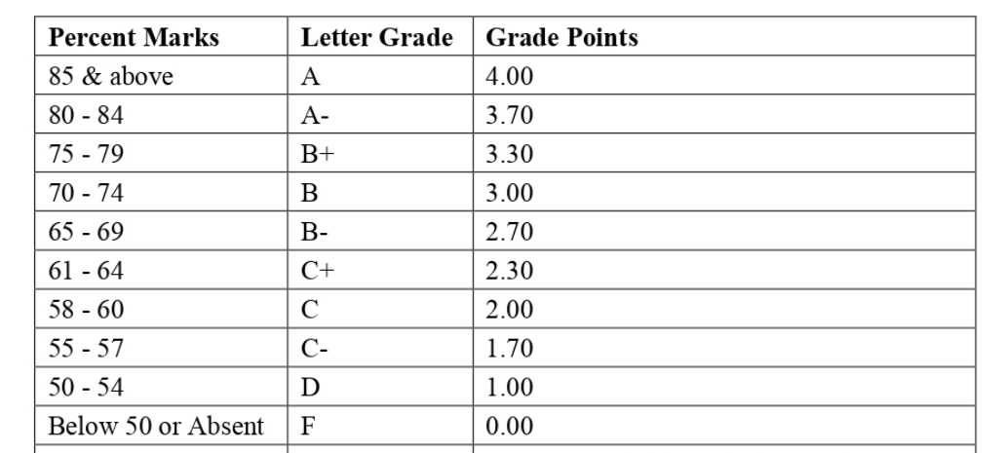

Task 03: Age Group Categorization Task
Design an algorithm which asks the user to enter a 3-digit positive integer. Then, the algorithm should calculate and display the sum of the digits of that integer. For example, if the user enters 786, then your algorithm should display 21 on screen.

Submissions:
  - For In-Lab Activity:
    - Save the files on your PC.
    - TA’s will evaluate the tasks online

References and Additional Material:
  - if…else Statement in C
https://www.programiz.com/c-programming/c-if-else-statement

  - for-loop Statement in C
https://www.programiz.com/c-programming/c-for-loop

  - do-while Statement in C
https://www.programiz.com/c-programming/c-do-while-loops

  - switch-case Statement in C
https://www.programiz.com/c-programming/ c-switch-case-statement

  - break-continue Statement in C
https://www.programiz.com/c-programming/c-break-continue-statement

